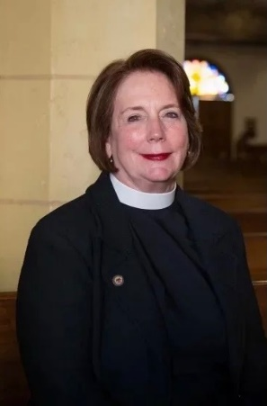
The Rev’d Eleanor Lynch Ellsworth, OStJ, has a background in public administration and librarianship in academic, special and public sectors prior to being ordained as priest in the Episcopal Church. On the faculty of the University of Tennessee School of Library and Information Science and then the University Library Staff Development Officer, she later became the Director of the National Rehabilitation Information Center at the Catholic University of America (CUA), a federally funded special library. She also served in the capacity of personnel analyst and personnel trainer for the Tennessee Valley Authority and consultant for the Office of Personnel Management before joining the faculty of Catholic University.
Community service has always been central to her life. From early days in the Junior League she has served in leadership on boards of directors of several schools, including the Knoxville Early Child Development Center she co-founded in the 1970’s. Schools include: The Norwood School (Bethesda, MD); St. Andrew’s Episcopal School (Potomac, MD); Ivymont School (Bethesda, MD); and the Board of Governors of the National Association of Episcopal Schools (NAES). In California she served on the Boards of the La Jolla Music Society, Rotary International, The Foundation for Women and Bodhi Tree Concerts. Her work with the University of California’s 21st Century China Center is ongoing. She also currently serves on the board of the American Friends of Gladstone’s Library (Wales), a unique Anglican institution.
Eleanor has had the opportunity to serve in both school and parish settings in Maryland, Tennessee and California as Chaplain and Teacher in schools and as Associate and Sr. Associate Rector, and Rector in various parishes. She has been ordained 30 years and is a certified Interim minister. Retired from active ministry, she is associated with Emmanuel Episcopal Church in Chestertown, Maryland.
Eleanor became a member of the Order of St. John in 2015. That year she was invited to be Celebrant for the International Convocation of the Johanniter Order in Washington, DC. She had previously engaged in activities with the Johanniter DC Cluster with her now deceased husband, a Knight of Justice. Currently she serves on the OSJ Committee to strengthen bonds with members of the Johanniter Order, participates in OSJ liturgical and educational services, and looks forward to going on pilgrimage to visit the St. John Eye Hospital Group.

