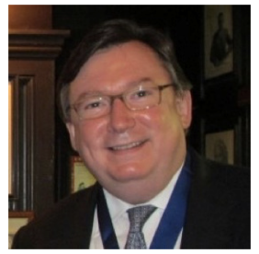
Michael D. Yon, OStJ, is experienced as a mechanical engineer in the defense industry, and he subsequently spent over 30 years advising large private and public corporations as an international investment banker and retired from JP Morgan Chase as a Managing Director. He is a former Director of the Hotel des Artistes, a cooperative apartment house in New York City where he lives with his wife, Kinne. Michael is a collector and investor in fine wines and is a Grand Officier of the Confrérie des Chevaliers du Tastevin, the noted Burgundy wine fraternity headquartered at the Château du Clos de Vougeot.

In 1997, Michael was elected to membership of The Lotos Club, one of the oldest literary clubs in the United States. He is the recipient of the Lotos Medal of Merit, and he was elected president of The Lotos Club in 2014, serving the four-year term. Michael was subsequently elected president of The Lotos Foundation, a public charity committed to encouraging gifted students and young creative artists in the fine and performing arts and sciences in New York City.

Michael is the son of a career Department of the Army Test Engineer, and he spent his youth near Edgewood Arsenal in Maryland. He received his Bachelor of Mechanical Engineering and Bachelor of Engineering Administration at the University of Delaware. He earned a Master of Business Administration from New York University, and subsequently he worked in project finance and private and public bond origination and execution.

Michael was appointed to the Order of St John in 2020, and he was proposed by Treasurer of the U.S. Priory, John Macaskill. Michael is currently the chair of the Development Subcommittee of the New York Region, and he also works closely with the Greenwich Region’s Development Subcommittee in a joint fundraising effort to build the Regions’ Nurses & Doctors Endowment.

